CHAPTER 4: Ecosystems
Worksheet 4.2

Food webs
Science Quest 7: pages 122–127
Student: Class:
Many animals eat more than one type of food. This means that they are in more than one food chain. Add arrows to the diagram below to join a number of food chains together to produce a food web. Note that some animals, such as the seagull, may actually be in more than one level, depending on which chain you follow to the top. A food web also has decomposers. Decomposers are organisms, such as bacteria, worms and fungi, that break down dead animals and plants. The nutrients in the dead animals and plants are recycled back into the food web.
Herbivores, such as the green turban snail, eat the plants and are called first-order consumers. Carnivores, such as the dog whelk, that eat first-order consumers are known as second-order consumers. The seagull is a third-order consumer because it eats the second-order consumer.
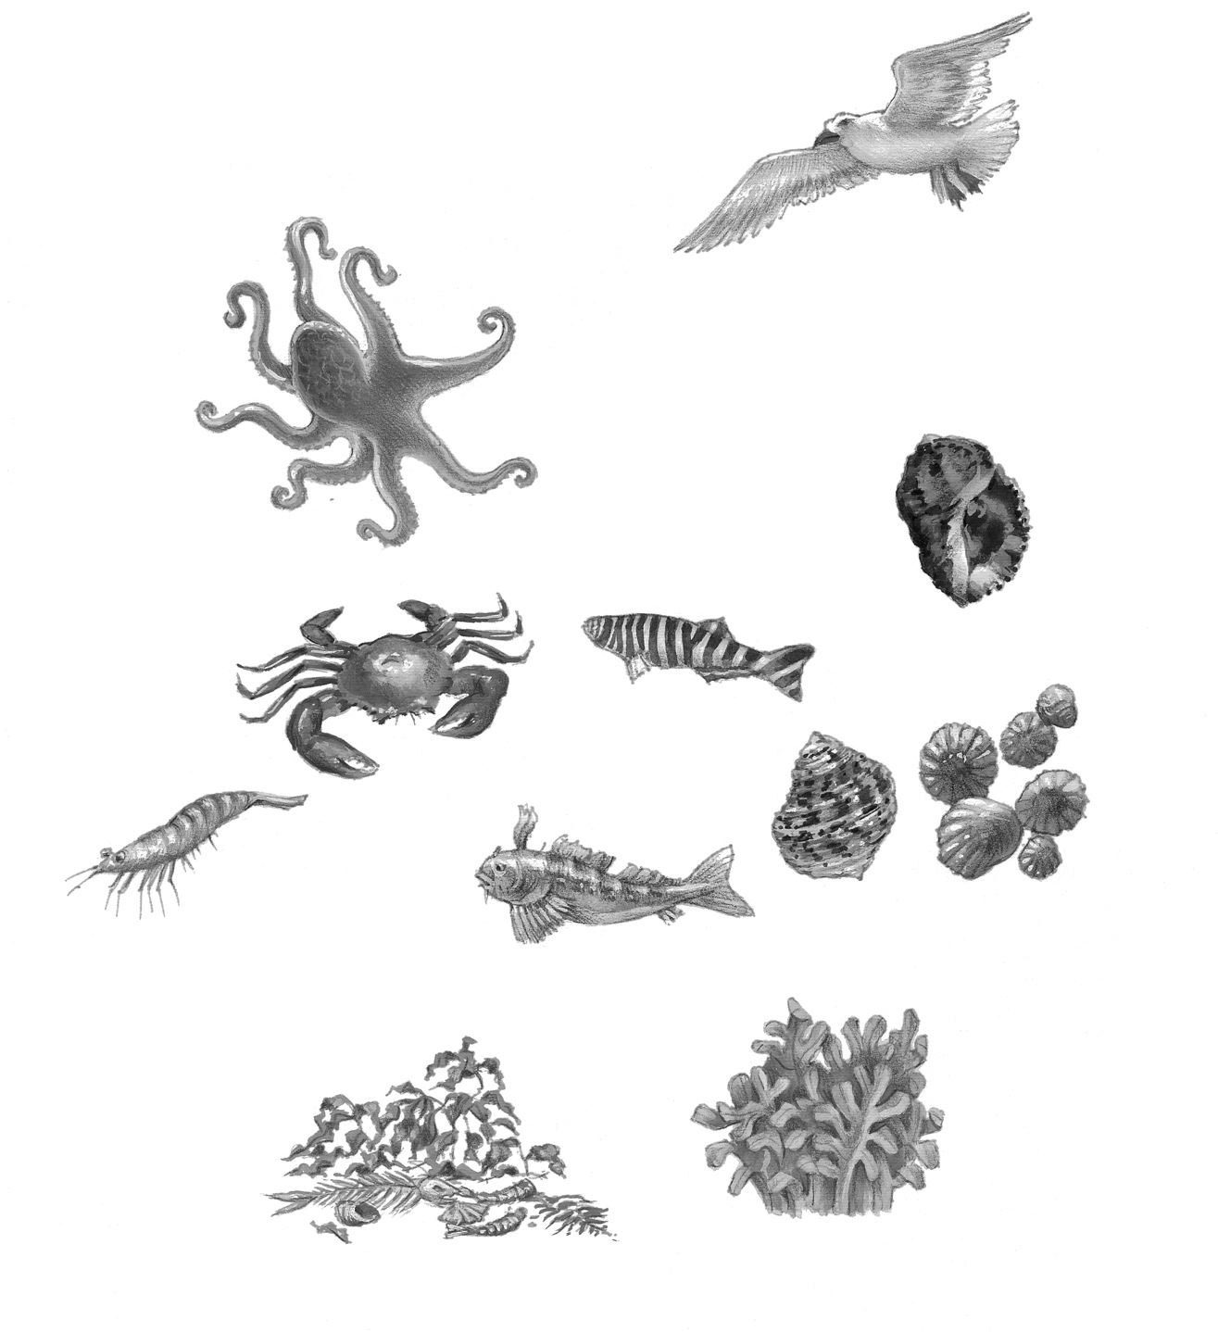
Green
turban
Snail
Zebra fish
Blenny
Seaweed
and algae
Dead and
decaying material
Shrimp
Crab
Limpets
Dog whelk
Octopus
Seagull

